Name:

Biogeochemical Cycles

The Water Cycle:

MODEL 1 - The Water Cycle
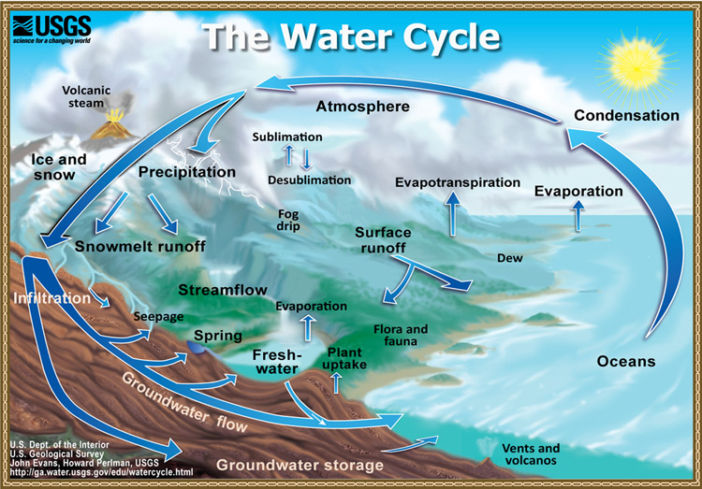

Use the information from the link to the USGS Water Science to answer the following questions.

- What percent of the water on earth is saline, or salt water? Where is most of that water stored?

- Of the freshwater available on Earth, where are the 2 major places it is stored and what percentage of freshwater do they store?

Use the table at the bottom of the USGS Water Science website to answer the following four questions:
- What percent of freshwater does the atmosphere store?

- What percent of freshwater do lakes store?

- What percentage of freshwater do rivers store?

- What percentage of freshwater is stored in biological organisms?

- Where do most humans get their water supply from?

- Model 1 illustrates the Water Cycle. Two process that convert liquid water to vapor are evaporation and transpiration. Search and define these two terms.

- What ways does Model 1 illustrate water on land returning to the ocean?

- Rain, sleet, and snow are examples of what?

- If the air contains high levels of pollutants, what effect might this have on water quality?

- Which process(es) of the water cycle - precipitation, evaporation, condensation, runoff, infiltration, or transpiration - might contribute to the addition of pollutants to rivers, lakes, and oceans? Why?

- Which of the processes associated with the water cycle might be responsible for helping clean or filter the water?

- Review Question! Water has many unique properties that make it so important for life. Name and describe three of these properties.

Use the information from the link to the Humans and the Water Cycle website to answer the following questions.
- What 4 major ways do humans affect the water cycle?

- How can mismanaged dams affect the water cycle and the surrounding environment?

- What is irrigation?

- What problems can occur due to improper irrigation?

- How do trees contribute to the water cycle?

- How can deforestation affect the water cycle?

- How can the burning of fossil fuels impact the water cycle?

- The water cycle is a closed system, meaning no water enters from beyond the system nor leaves the system. What does that say about the importance of keeping the water on Earth free from pollution?

The Carbon Cycle:

MODEL 1 - The Carbon Cycle
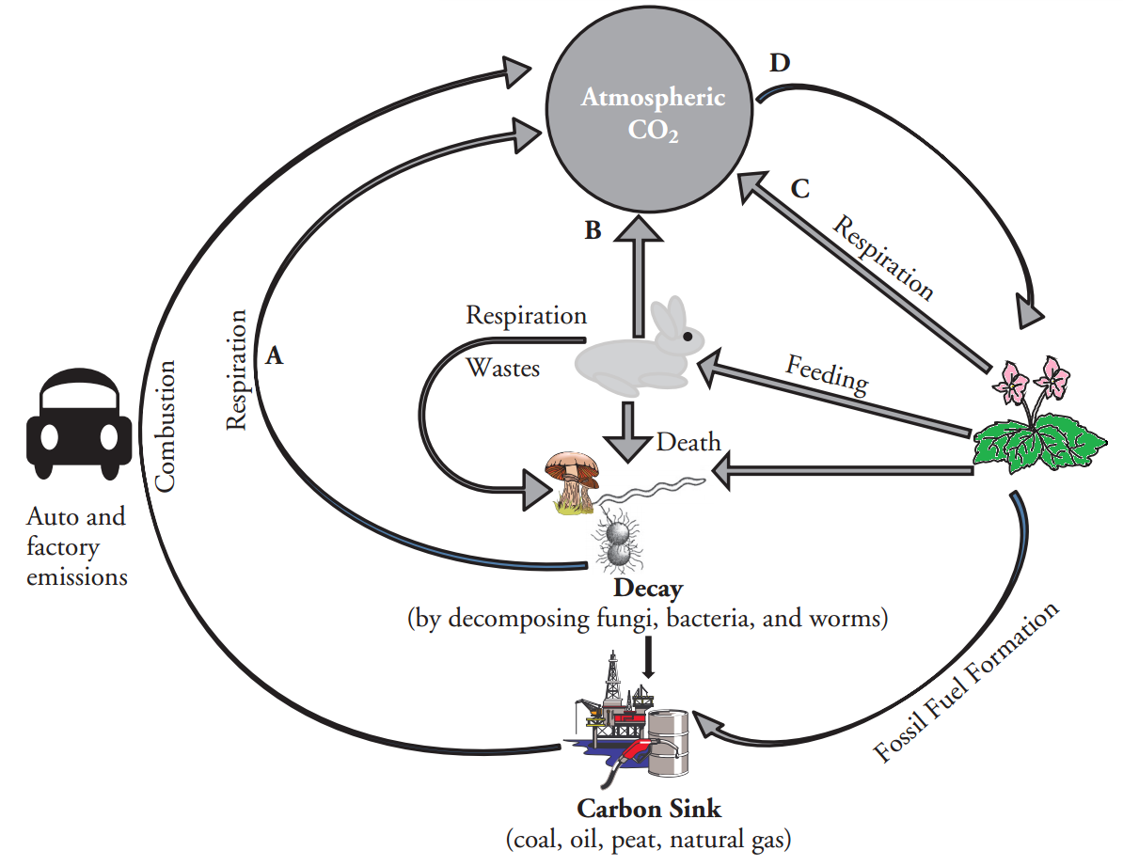
- Model 1 illustrates how nature recycles what natural resource?

- Review Question! What makes carbon so uniquely suited to form so many different kinds of molecules? HINT: remember how many electrons it has and needs!

- Name two ways that carbon (usually in the form of CO2) enters the atmosphere.

- Processes B and C on the diagram are returning carbon back into the atmosphere from plants and animals. What is the name of this process?

- What cellular structure performs the above process?

- Write the equation that goes along with the above process.

- Process D on the diagram uses CO2 from the atmosphere and transfers it to plants. What is the name of this process?

- What cellular structure performs the above process?

- Write the equation that goes along with the above process.

- Wastes and dead organisms must be broken down in order for their components to be used again. What organisms in the cell cycle carry out this process?

- What would happen if decomposition did not occur?

- Not all dead organisms are acted on by decomposers. Instead of being immediately recycled, the carbon from some organisms is kept in a type of long-term storage, or carbon sink. List the four materials that contain this stored carbon.

- What is the collective term for these four materials?

- How do humans use the material in the carbon sink?

Lesson 1: The Carbon Cycle

Data Table 1.1
Net Deforestation Rate: 1 GT Change in fossil fuel use per year: 2%
 | Gaseou Carbon | Ocean Water |  | Fossil Fuels |  | Biosphere Gaseous Carbon
To Year | Atmosphere | Ocean Surface | Deep Ocean | Oil and Gas | Coal | Soil | Terrestrial Plants
2010
2020
2030
2040
2050
2060
2070
2080
2090
2100
2010

- What sinks change the most through the hundred year simulation?

- Why doesn’t the carbon recycle back into the fossil fuel sinks?

- At what year did the atmospheric CO2 levels surpass the simulator’s goal of 550 ppm?

Lesson 2: Curbing Emissions
- In a best-case (but very unrealistic) scenario, imagine that scientists suddenly discovered an unlimited, clean, and cheap fuel source that emitted no CO2 into the atmosphere, thus bringing fossil fuel use down to zero. What would happen? Would the carbon cycle naturally bring atmospheric CO2 levels back to pre-industrial levels (below 280 ppm)? Make a hypothesis stating your prediction on how atmospheric CO2 levels will look if we brought fossil fuel use to zero.

Data Table 2.1
 |  |  | Gaseous Carbon
To Year | Net Deforestation Rate | Fossil Fuel % Increase | Atmosphere
2010
2060
2110

- How have atmospheric carbon levels changed?

- Without any fossil fuel consumption, did atmospheric CO2 drop to pre-industrial revolution levels (below 280 ppm) within the hundred year time frame?

- The elevated levels of atmospheric CO2 caused by a century of fossil fuel burning will continue to impact the carbon cycle because the system attempts to reach a state of equilibrium, with the exception of the gradual moving of carbon from the surface to the deep ocean, which happens only over longer time-scales. It could take 2000 years or more for this process to restore atmospheric CO2 to pre-industrial levels. Does that mean we permanently affected our atmosphere?

- Reducing carbon emissions to zero is far from realistic. Many scientists agree that a doubling of the pre-industrial CO2 concentration to approximately 550 ppm is a reasonable target to shoot for in order to avoid the most serious impacts on climate and ecosystems.Write a hypothesis stating your prediction on how atmospheric CO2 levels will look if we reduce fossil fuel use to 0.2% per year and reduce deforestation to 0.5 GT per year.

Table 2.2
 |  |  | Gaseous Carbon
To Year | Net Deforestation Rate | Fossil Fuel % Increase | Atmosphere
2010
2060
2110

- Did atmospheric CO2 concentration reach 550 ppm by 2110?

- Did your results match your hypothesis? Explain.

- In order to keep atmospheric concentration levels below 550 ppm by 2110 we need to drastically reduce our fossil fuel increase and reduce deforestation by 50%. Currently we are increasing our energy demand by 2% per year (2.5% increase was seen during 2000-2010!). Do you think we can realistically reduce fossil fuel use to 0.2% Explain your answer!

- Ninety-seven percent or more of actively publishing climate scientists accept that climate change is happening and the number one suspect is human activities. Many people continue to ignore scientists and their concern. What would happen if we continued to increase our fossil fuel and deforestation activities? Make a hypothesis stating your prediction on how atmospheric CO2 levels will look if we increase fossil fuels to 4% per year and increase deforestation to 4 GT per year.

Table 2.3
 |  |  | Gaseous Carbon
To Year | Net Deforestation Rate | Fossil Fuel % Increase | Atmosphere
2010
2040
2060
2080
2110

- At what year did atmospheric CO2 concentration reach 550 ppm?

- Did atmospheric CO2 concentration increase until 2110?

- What caused the dramatic drop in atmospheric CO2 concentration levels?

Carbon Footprint:

- How many acres and Earths would be needed to sustain your family’s lifestyle?

- What was the average number of acres and Earths needed for the class?

- Which statistic would you use if you wanted to point out the lack of awareness of the environment? Which statistic would you use if you did not want to alarm the public?

- What is the biggest factor that contributes to a high number of acres?

- Which area do you think could conserve the most of the earth’s resources?

- Suppose you were to calculate the mean again eliminating the highest 3 values. Is the mean still greater than 1 Earth?

- What does that mean for future generations?

- Is it enough to change only the extreme lifestyles? Or does everyone need to change if we are to get the number down to below 1 Earth needed?

- What small, easy changes could be done that, as a collective whole, would make a significant difference?

